# CANDIDATE’S DECLARATION

We, hereby declare that the work presented in this project entitled “Designing and Implementing Wide Area Network Using OSPF Protocol ” in the partial fulfillment of the requirements for the award of the Degree of Bachelor of Technology in Computer Science & Engineering at JECRC University, Jaipur is an authentic work of our own.

We have not submitted the matter embodied in this project work anywhere for the award of degree of Bachelor of Technology in Computer Science & Engineering.

**Student Name - Devansh Khandelwal Univ. Roll No. – 21BCON078**

**Date:**

**Place:**

BONAFIDE CERTIFICATE

This is to certify that the project entitled " **Designing and Implementing Wide Area Network Using OSPF Protocol** " is the bonafide work carried out **by Devansh Khandelwal(21BCON078), Arpit Sharma(21BCON067),**  students of B.Tech. in Computer Science & Engineering at JECRC University, during the year 2023-24 in partial fulfillment of the requirements for the award of the Degree of Bachelor of Technology in Computer Science & Engineering and the project has not formed the basis for the award previously of any degree, diploma, fellowship or any other similar title.

**Name of Guide**

**Designation**

**Place:**

**Date:**

**VISION OF CSE DEPARTMENT**

To become renowned Centre of excellence in computer science and engineering and make competent engineers and professionals with high ethical values prepared for lifelong learning.

**MISSION OF CSE DEPARTMENT**

1. To impart outcome based education for emerging technologies in the field of computer science and engineering.
2. To provide opportunities for interaction between academia and industry.
3. To provide platform for lifelong learning by accepting the change in technologies.
4. To develop aptitude of fulfilling social responsibilities.

**PROGRAM OUTCOMES (POs)**

1. **Engineering knowledge:** Apply the knowledge of mathematics, science, engineering fundamentals, and an engineering specialization to the solution of complex engineering problems.
2. **Problem analysis**: Identify, formulate, research literature, and analyze complex engineering problems reaching substantiated conclusions using first principles of mathematics, natural sciences, and engineering sciences.
3. **Design/development of solutions**: Design solutions for complex engineering problems and design system components or processes that meet the specified needs with appropriate consideration for the public health and safety, and the cultural, societal, and environmental considerations.
4. **Conduct investigations of complex problems**: Use research-based knowledge and research methods including design of experiments, analysis and interpretation of data, and synthesis of the information to provide valid conclusions.
5. **Modern tool usage**: Create, select, and apply appropriate techniques, resources, and modern engineering and IT tools including prediction and modeling to complex engineering activities with an understanding of the limitations.
6. **The engineer and society**: Apply reasoning informed by the contextual knowledge to assess societal, health, safety, legal and cultural issues and the consequent responsibilities relevant to the professional engineering practice.
7. **Environment and sustainability**: Understand the impact of the professional engineering solutions in societal and environmental contexts, and demonstrate the knowledge of, and need for sustainable development.
8. **Ethics**: Apply ethical principles and commit to professional ethics and responsibilities and norms of the engineering practice.
9. **Individual and team work**: Function effectively as an individual, and as a member or leader in diverse teams, and in multidisciplinary settings.
10. **Communication**: Communicate effectively on complex engineering activities with the engineering community and with society at large, such as, being able to comprehend and write effective reports and design documentation, make effective presentations, and give and receive clear instructions.
11. **Project management and finance**: Demonstrate knowledge and understanding of the engineering and management principles and apply these to one’s own work, as a member and leader in a team, to manage projects and in multidisciplinary environments.
12. **Life-long learning**: Recognize the need for, and have the preparation and ability to engage in independent and life-long learning in the broadest context of technological change.

**PROGRAM EDUCATIONAL OBJECTIVES (PEOs)**

The PEOs of the B.Tech (CSE) program are:

**PEO1**:  To provide students with the fundamentals of Engineering Sciences with more emphasis in computer science and engineering by way of analyzing and exploiting engineering challenges.

**PEO2:** To train students with good scientific and engineering knowledge so as to comprehend, analyze, design, and create novel products and solutions for the real life problems.

**PEO3**: To inculcate professional and ethical attitude, effective communication skills, teamwork skills, multidisciplinary approach, entrepreneurial thinking and an ability to relate engineering issues with social issues.

**PEO4:** To provide students with an academic environment aware of excellence, leadership, written ethical codes and guidelines, and the self-motivated life-long learning needed for a successful professional career.

**PEO5**: To prepare students to excel in Industry and Higher education by educating Students along with High moral values and Knowledge.

**PROGRAM SPECIFIC OUTCOMES (PSOs)**

**PSO1:** Ability to interpret and analyze network specific and cyber security issues in real world environment.

**PSO2:** Ability to design and develop Mobile and Web-based applications under realistic constraints.

**COURSE OUTCOMES (COs)**

On completion of project Graduates will be able to-

* CO1: Gather, organize, summarize and interpret technical literature with the purpose of formulating a project proposal.
* CO2: Design/Develop the solution using latest technologies and communicate via modern tools.
* CO3 Understand and develop the professional, social ethics, and team management principles.

**MAPPING: CO’s & PO’s**

|  |  |  |  |  |  |  |  |  |  |  |  |  |  |  |  |
| --- | --- | --- | --- | --- | --- | --- | --- | --- | --- | --- | --- | --- | --- | --- | --- |
| **Subject** | **Code** | **L/T/P** | **CO** | **PO1** | **PO2** | **PO3** | **PO4** | **PO5** | **PO6** | **PO7** | **PO8** | **PO9** | **PO10** | **PO11** | **PO12** |
| **Project** | 8CS7-50 | P | Graduates will be able to: gather, organize, summarize and interpret technical literature with the purpose of formulating a project proposal. | 3 | 3 | 3 | 2 | 2 | 2 | 1 | 2 | 1 | 2 | 2 | 3 |
| P | Graduates will be able to: Design/Develop the solution using latest technologies and communicate via modern tools. | 3 | 3 | 3 | 2 | 2 | 2 | 1 | 2 | 2 | 2 | 2 | 3 |
| P | Graduates will be able to: Understand and develop the professional, social ethics, and team management principles. | 3 | 3 | 3 | 2 | 2 | 2 | 1 | 2 | 2 | 2 | 2 | 3 |

**ACKNOWLEDGEMENT**

We wish to express our deep sense of gratitude to our Project Guide Mr./Ms._______________________, JECRC University, Jaipur for guiding us from the inception till the completion of the project. We sincerely acknowledge him for giving his valuable guidance, support for literature survey, critical reviews and comments for our Project.

We would like to first of all express our thanks to **Mr. Arpit Agrawal** Director of JECRC, for providing us such a great infrastructure and environment for our overall development.

Words are inadequate in offering our thanks to **HOD Name,** HOD of CSE department, for consistent encouragement and support for shaping our project in the presentable form.

We also like to express our thanks to all supporting CSE faculty members who have been a constant source of encouragement for successful completion of the project.

Also, our warm thanks to **JECRC University**, who provided us this opportunity to carryout, this prestigious Project and enhance our learning in various technical fields.

**Student Name-Univ. Roll No.**

**ABSTRACT**

This project deals with the design and simulation of a Wide Area Network and a topology which consists of 10 networks. After that, Implement the scenario using OSPF Protocol (multi Area Concept).

The project consists of 10 different networks with class-C IP Addresses starting from (198.100.1.0 - 198.100.1.144). This Consists of a Wide Area Network for data communication that operates beyond the geographic scope of a Local Area Network We have used DHCP, Web and DNS server in the network. In this, OSPF (Open Shortest Path First) Protocol is used to find the best path between the source and the destination through a link.

OSPF is a link state routing protocol that uses a database of the network’s topology to determine the best route for data packets to take from their source to their destination.

**TABLE OF CONTENTS**

**Candidates Declaration------------------------------------------------------------------------- i**

**Bonafide Certificate------------------------------------------------------------------------------ ii**

**Vision and Mission------------------------------------------------------------------------------- iii**

**Program Outcomes (POs)----------------------------------------------------------------------- iv**

**Program Education Objectives (PEOs) ------------------------------------------------------ v**

**Program Specific Outcomes (PSOs)----------------------------------------------------------- v**

**Course Outcomes (COs)------------------------------------------------------------------------- vi**

**Mapping: COs and POs-------------------------------------------------------------------------- vi**

**Acknowledgement--------------------------------------------------------------------------------- vii**

**Abstract---------------------------------------------------------------------------------------------- viii**

**List of Figures--------------------------------------------------------------------------------------- ix**

**List of Tables---------------------------------------------------------------------------------------- x**

**1. INTRODUCTION------------------------------------------------------------------------------ 1**

* 1. Purpose --------------------------------------------------------------------------------------- 2
  2. Project Scope--------------------------------------------------------------------------------- 3
  3. Document Convention ---------------------------------------------------------------------- 4

**2. REQUIREMENT ANALYSIS--------------------------------------------------------------- 10**

2.1 Hardware Requirement--------------------------------------------------------------------- 11

2.2 Software Requirement ---------------------------------------------------------------------- 12

2.3 Functional Requirement--------------------------------------------------------------------- 13

2.4 Non Functional Requirements ------------------------------------------------------------ 13

2.5 User Classes and Characteristics ----------------------------------------------------------- 14

**3. SYSTEM DESIGN------------------------------------------------------------------------------- 22**

3.1 Use Case Diagram--------------------------------------------------------------------------- 23

3.2 Data Base Design and Databases --------------------------------------------------------- 24

3.3 Sequence Diagram/Activity Diagram------------------------------------------------------ 25

3.4 Deployment Diagram ---------------------------------------------------------------------- 27

**4. SCREEN SHOTS-------------------------------------------------------------------------------- 38**

**5. TESTING ----------------------------------------------------------------------------------------- 46**

**6. LIMITATIONS OF PROJECT--------------------------------------------------------------- 50**

**7. FUTURE SCOPE OF PROJECT------------------------------------------------------------- 55**

**8. REFERENCES----------------------------------------------------------------------------------- 56**

**Appendix A: Project Proposal..…………………………………………………………**

Error! Bookmark not defined.**9**

**Introduction**

**Purpose:**

**Purpose of the Project in Detail:**

The purpose of the project is multifaceted and aims to address several key objectives and goals within the context of implementing OSPF (Open Shortest Path First) in a Wide Area Network (WAN) environment. The detailed purposes of the project include:

**Enhancing Network Efficiency**: One of the primary purposes of implementing OSPF is to enhance the efficiency of network routing and data transmission within the WAN. OSPF's dynamic routing capabilities, including shortest path calculations and adaptive routing, help optimize network resources and reduce latency in data delivery.

**Improving Network Scalability**: By deploying OSPF, the project seeks to improve the scalability of the network infrastructure, enabling seamless expansion and growth as the network evolves. OSPF's hierarchical area structure and scalability features support the addition of new routers, subnets, and network segments without compromising performance.

**Ensuring Network Redundancy and Fault Tolerance**: OSPF implementation includes features such as route redundancy, failover mechanisms, and fast convergence times, ensuring high network availability and fault tolerance. The project aims to design OSPF configurations that minimize network downtime and maintain continuous connectivity in the event of link failures or router outages.

**Facilitating Network Management and Monitoring**: OSPF provides robust network management capabilities, including real-time monitoring of routing metrics, neighbor relationships, and routing table updates. The project's purpose includes leveraging OSPF's management features to streamline network monitoring, troubleshooting, and performance optimization.

**Enhancing Security and Control:** OSPF authentication mechanisms and access control policies are utilized to enhance network security and prevent unauthorized access to routing information. The project aims to implement OSPF security measures that safeguard routing updates, prevent routing table manipulation, and mitigate potential network attacks.

**Supporting Dynamic Network Environments:** The project's purpose extends to supporting dynamic network environments with varying traffic patterns, network topologies, and routing requirements. OSPF's adaptability and flexibility in adjusting to changing network conditions make it suitable for dynamic WAN environments with diverse connectivity needs.

**Optimizing Resource Utilization:** OSPF's ability to calculate optimal routing paths based on network metrics and link costs contributes to efficient resource utilization across the WAN. The project aims to design OSPF configurations that minimize network congestion, balance traffic loads, and optimize bandwidth utilization for improved network performance.

In summary, the purpose of the project is to deploy OSPF in a WAN environment to enhance network efficiency, scalability, fault tolerance, security, management capabilities, and resource utilization. These objectives align with the project's overarching goal of creating a robust and reliable network infrastructure that meets the evolving needs of modern data communication and networking.

**Background of the Study:**

The evolution of network infrastructures and the emergence of dynamic routing protocols like OSPF. It traces the historical development of computer networks from simple Local Area Networks (LANs) to the complex, interconnected systems that power modern organizations and businesses.

Initially, networks relied heavily on static routing, where administrators manually configured routing tables to determine the paths data packets would take through the network. While effective for small-scale setups, static routing proved cumbersome and inefficient as networks grew larger and more interconnected.

The need for more dynamic and adaptive routing solutions led to the development of dynamic routing protocols such as OSPF. OSPF, introduced in the late 1980s, revolutionized network routing by enabling routers to communicate with each other, exchange routing information, and dynamically calculate the shortest paths for data packets based on real-time network conditions.

**Project Scope:**

1. OSPF Configuration and Optimization

Best practices for OSPF configuration

Optimization of OSPF parameters

1. OSPF Integration with Other Routing Protocols

Integration with BGP and EIGRP

OSPF redistribution and route summarization.

1. Impact of OSPF on Network Resilience

Providing network redundancy and failover

Fast convergence during failures

1. Future Trends and Innovations in OSPF

Emerging trends in OSPF technology

Anticipated advancements in OSPF protocols

**Document Convention**

This Project includes a Wide Area Network of 10 different networks. These network consists of PCs, Web Server, DNS and DHCP Servers. The OSPF(Open Shortest Path First) is used for routing the network to find the best path between the source and the destination. To find the best path, We have configured all the routers according to OSPF configuration. We have also subnetted the IP Address 198.100.0.0 to 10 different networks. The area in the network carried out by OSPF routing works well, so that the information dissemination becomes faster and more efficient.

* A Wide Area Network is a data communication network that operates beyond the geographic scope of a Local Area Network.
* Dynamic routing is a process where a router can forward data via a different route for a given destination based on the current conditions of the communication circuits within a system.
* OSPFis a link state routing protocol that is used to find the best path between the source and the destination

**OSPF:**

Open Shortest Path First (OSPF) is a routing protocol that is used to find the shortest path for data to travel from one network to another. It is used in Internet Protocol (IP) networks and is a link-state protocol, which means that it stores information about the entire network and all its components in a database, and then uses this information to calculate the shortest path to a destination.

OSPF is a widely used routing protocol in large enterprise networks and is also used in some service provider networks. It is known for its fast convergence, which means that it can quickly adjust to changes in the network, such as the addition or removal of a device or link. OSPF can also support multiple equal-cost paths to a destination, allowing for load balancing redundancy.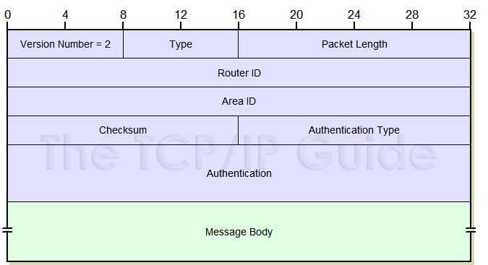

fig : OSPF header

The OSPF header is the part of an OSPF packet that contains information about the packet itself, such as its type, length, and checksum. The OSPF header consists of several fields, each of which has a specific purpose. The fields in the OSPF header are:

Version: This field indicates the version of the OSPF protocol being used.

Type: This field specifies the type of OSPF packet, such as a hello message, a database description message, or a link-state request message.

Packet length: This field specifies the length of the OSPF packet, including the header and any additional data.

Router ID: This field contains the unique identifier of the router that originated the packet.

Area ID: This field specifies the area to which the packet belongs.

Checksum: This field contains a checksum value that is used to verify the integrity of the packet.

Autonomous System (AS) number: This field specifies the AS to which the packet belongs.

Authentication: This field is used to authenticate the packet and ensure that it was not tampered with.

The OSPF header is followed by additional data, depending on the type of OSPF packet. For example, a hello message might contain information about the state of the link.

**2. REQUIREMENT ANALYSIS**

**Hardware Requirement**

Routers High-performance routers capable of running OSPF protocols and handling multiple network interfaces.

Switches Managed switches with VLAN support for network segmentation and optimization.

Network Interfaces Sufficient network interfaces for connecting LANs, WAN links, and backbone networks.

Servers Depending on the network size, servers for hosting OSPF management tools, monitoring systems, and network services.

Network Cables Ethernet cables, fiber optic cables, and connectors for network connectivity.

**Software Requirement**

Operating Systems Compatible operating systems for routers and switches supporting OSPF configurations (e.g., Cisco IOS, Juniper Junos).

OSPF Implementation Software OSPF routing software for configuring OSPF routing tables, areas, and parameters.

Network Management Software Tools for monitoring OSPF performance, troubleshooting network issues, and analyzing routing metrics.

Simulation Software Network simulation software (e.g., Cisco Packet Tracer, GNS3) for testing OSPF configurations and network designs.

**Functional Requirement**

OSPF Configuration Ability to configure OSPF routing protocols, areas, interfaces, and metrics.

Route Optimization Optimizing OSPF routing tables to ensure efficient data transmission and path selection.

Failover Mechanism Implementing OSPF failover mechanisms for network redundancy and fault tolerance.

Security OSPF authentication mechanisms for securing OSPF routing updates and preventing unauthorized access.

Monitoring and Reporting Tools for monitoring OSPF performance metrics, generating reports, and alerting network administrators to potential issues.

**Non-Functional Requirements**

Performance OSPF implementation should be optimized for fast convergence, minimal routing overhead, and low latency.

Scalability OSPF should scale effectively with network growth, supporting a large number of routers, areas, and network segments.

Reliability OSPF should provide reliable routing services, with built-in mechanisms for error detection, correction, and recovery.

Security OSPF authentication and encryption mechanisms to secure OSPF routing updates and prevent network attacks.

Usability User-friendly interfaces and configuration tools for easy OSPF management and troubleshooting.

**User Classes and Characteristics**

Network EngineersAdministrators Experienced professionals responsible for designing, implementing, and managing OSPF-based networks. They require in-depth knowledge of OSPF configuration, optimization, troubleshooting, and network performance monitoring.

System Integrators Professionals involved in integrating OSPF with other network technologies, protocols, and services. They require expertise in OSPF interoperability, compatibility testing, and seamless integration with existing network infrastructures.

Network Operators Personnel responsible for day-to-day network operations, monitoring OSPF performance, handling network incidents, and ensuring network reliability and uptime. They require tools and training for efficient OSPF management and incident resolution.

**SYSTEM DESIGN**

# Major Design Areas and Functional Areas

The new system planned comprises of IP based switches that remain as the access point to lan-based (ethernet) as well as Wi-Fi-based connectivity.

These switches provide SNMP support as well so that traffic monitoring becomes easy. Ip based switches are used mainly because:

* The inter VLAN routing feature is supported on both IP base or SMI and IP services or EMI image Layer 3 switches. For Layer 2-only switches, you require a Layer 3 routing device with any of the previous images.

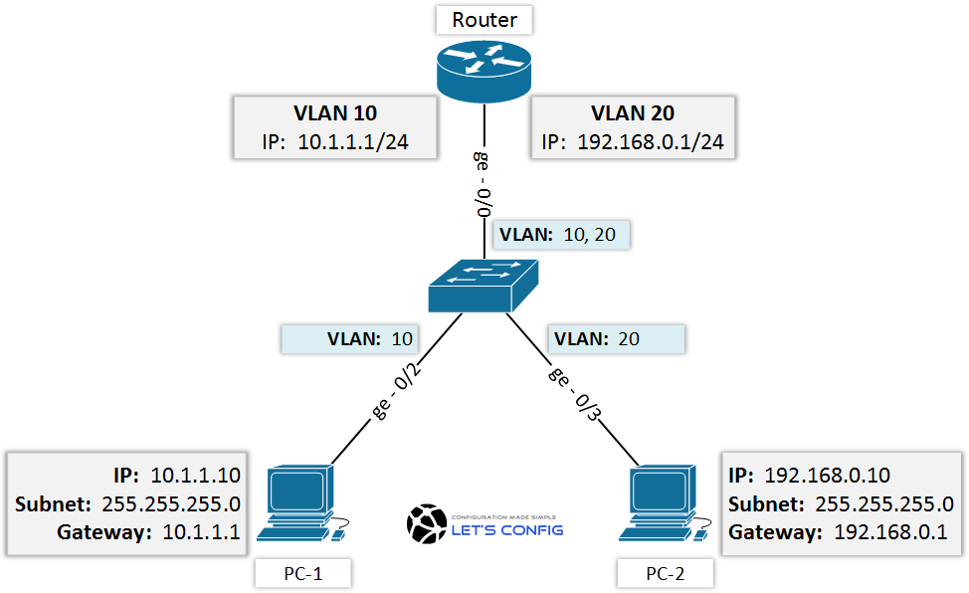

* The IP Base feature set includes advanced quality of service (QoS), rate limiting, access control lists (ACLs), and basic static and Routing Information Protocol (RIP) functions. Dynamic IP routing protocols (Open Shortest Path First (OSPF), BGPv4, Enhanced Interior Gateway Routing Protocol (EIGRP)) are available only on the IP services image.
* The IP Services image provides a richer set of enterprise-class features, which includes advanced hardware-based IP unicast and IP Multicast routing. Support for IPv6 Layer 3 switching in hardware is also available with the addition of the Advanced IP Services license to either the IP Base or the IP Services images. Both the IP base Image and the IP services image allow for Layer 3 and Layer 4 lookups for QoS and security.

**Real time and Simulation Mode Results :**

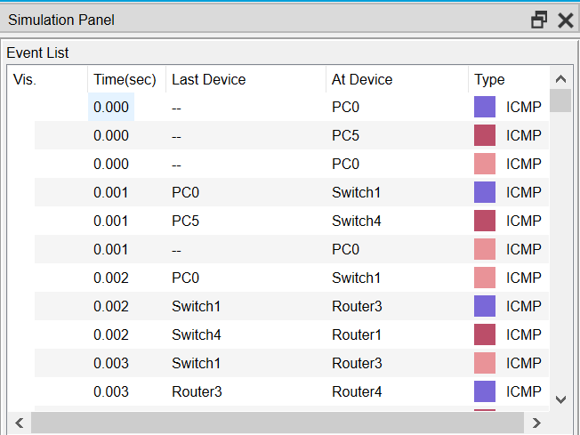

# Existing Infrastructure

The existing system is a very basic system. College mainly comprises of three main sections as

1. TPO & Other
2. Exam Center
3. Office

All the hosts are assigned with static IPs and are assigned in the order in which it where set up. No support for dynamic IP allocations. Even though the working is divided into three major sectors all the host, multimedia devices are connected in a single network. Thus, network security and maintenance are difficult. One more problem observed was the existing switches were outdated and hence could not prove to be beneficial for the network administrator to observe monitor and handle the network traffic the system has no remote access to the network. Absence of basic small-scale businesses firewall was also observed. Thus, security is also compromised. Three server rooms were used for the purpose of independent networking which further caused wastage of power and money.

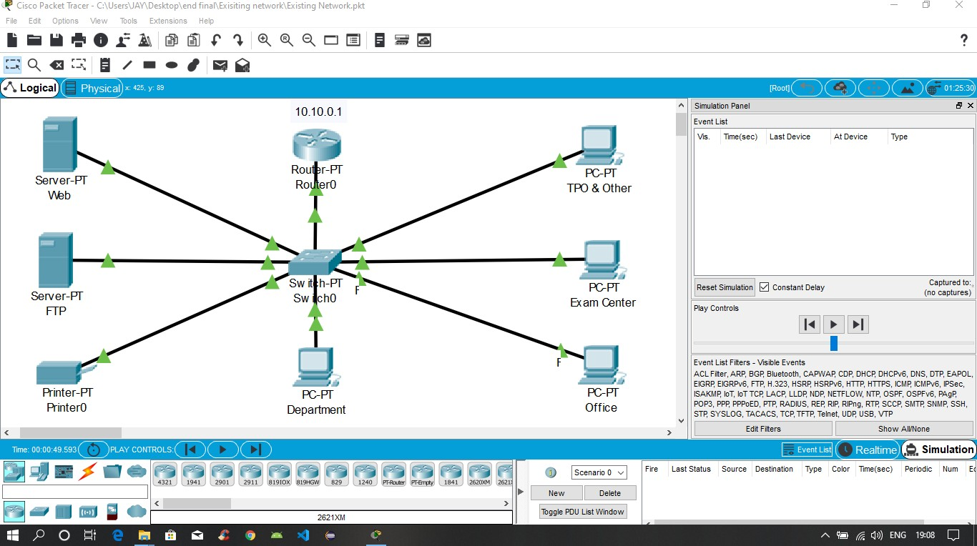

# Network Devices

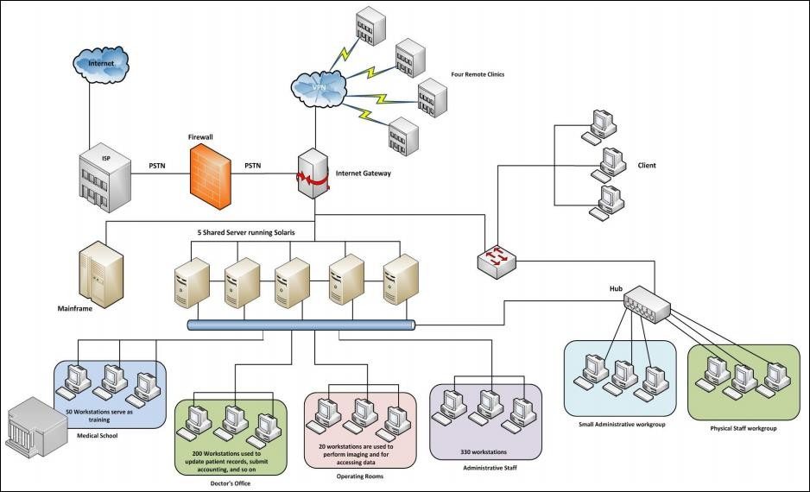

**IP Addressing Plan**

|  |  |
| --- | --- |
| **IT DEPARTMENT (192.168.1.0)** | |
| HOD CABIN | 192.168.1.2 |
| IT LAB 1 | 192.168.1.3 |
| IT LAB 2 | 192.168.1.4 |
| IT LAB 3 | 192.168.1.5 |
| IT LAB 4 | 192.168.1.6 |
| Printer 0 | 192.168.1.7 |

|  |  |
| --- | --- |
| **COMPUTER DEPARTMENT (192.168.2.0)** | |
| CS HOD CABIN | 192.168.2.2 |
| CS LAB 1 | 192.168.2.3 |
| CS LAB 2 | 192.168.2.4 |
| CS LAB 3 | 192.168.2.5 |
| CS LAB 4 | 192.168.2.6 |
| Printer 7 | 192.168.2.7 |

|  |  |
| --- | --- |
| **OTHERS (192.168.3.0)** | |
| OFFICE | 192.168.3.2 |
| Printer 2 | 192.168.3.6 |
| EXAM CELL | 192.168.3.3 |
| Printer 3 | 192.168.3.7 |
| ENQUIRY | 192.168.3.4 |
| TPO | 192.168.3.5 |
| Printer 4 | 192.168.3.8 |

|  |  |
| --- | --- |
| **SERVER ROOM (1.0.0.0)** | |
| FTP SERVER | 1.0.0.4 |
| PC1 | 1.0.0.5 |
| DNS SERVER | 1.0.0.2 |
| WEB SERVER | 1.0.0.3 |

|  |  |
| --- | --- |
| **INTERNET LAB (128.168.0.0)** | |
| PC2 | 128.168.0.2 |
| PC3 | 128.168.0.3 |
| PC4 | 128.168.0.4 |
| PC5 | 128.168.0.5 |
| Printer 5 | 128.168.0.6 |

|  |  |
| --- | --- |
| **PRINCIPLE ROOM (192.168.4.0)** | |
| PC 0 | 192.168.4.2 |
| LAPTOP 0 | 192.168.4.3 |

# Routing Protocol Plan

Routing Information Protocol (RIP) is a dynamic routing protocol which uses hop count as

a routing metric to find the best path between the source and the destination network. It is a distance vector routing protocol which has AD value 120 and works on the application layer of OSI model.

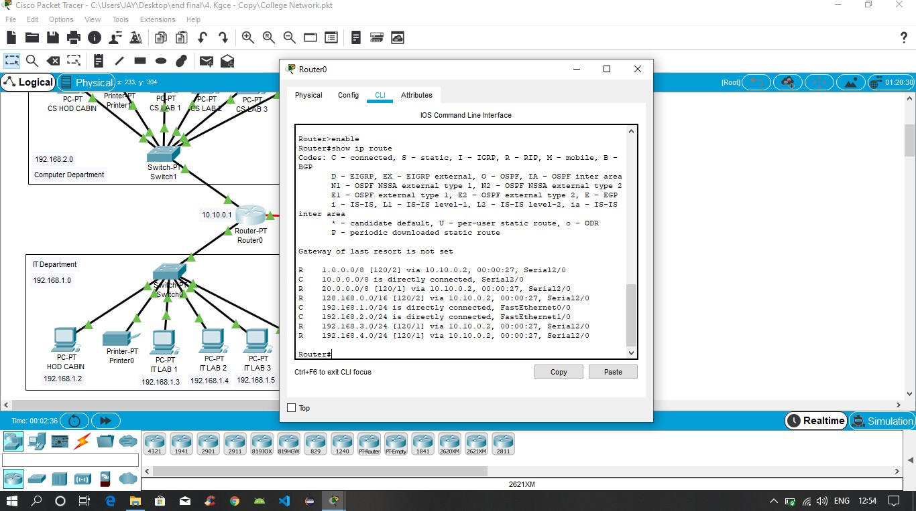

*Routing Protocol Plan for Router0*

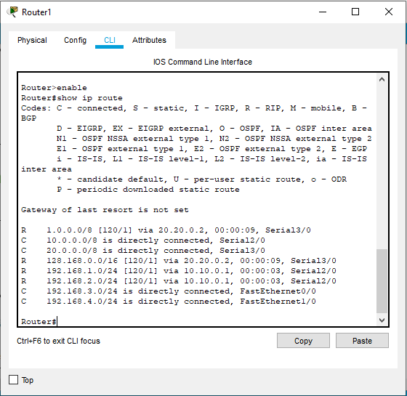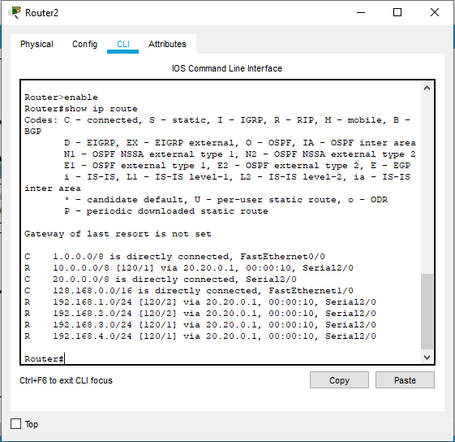

*Routing Protocol Plan for Router1 Routing Protocol Plan for Router2*

# Network Design

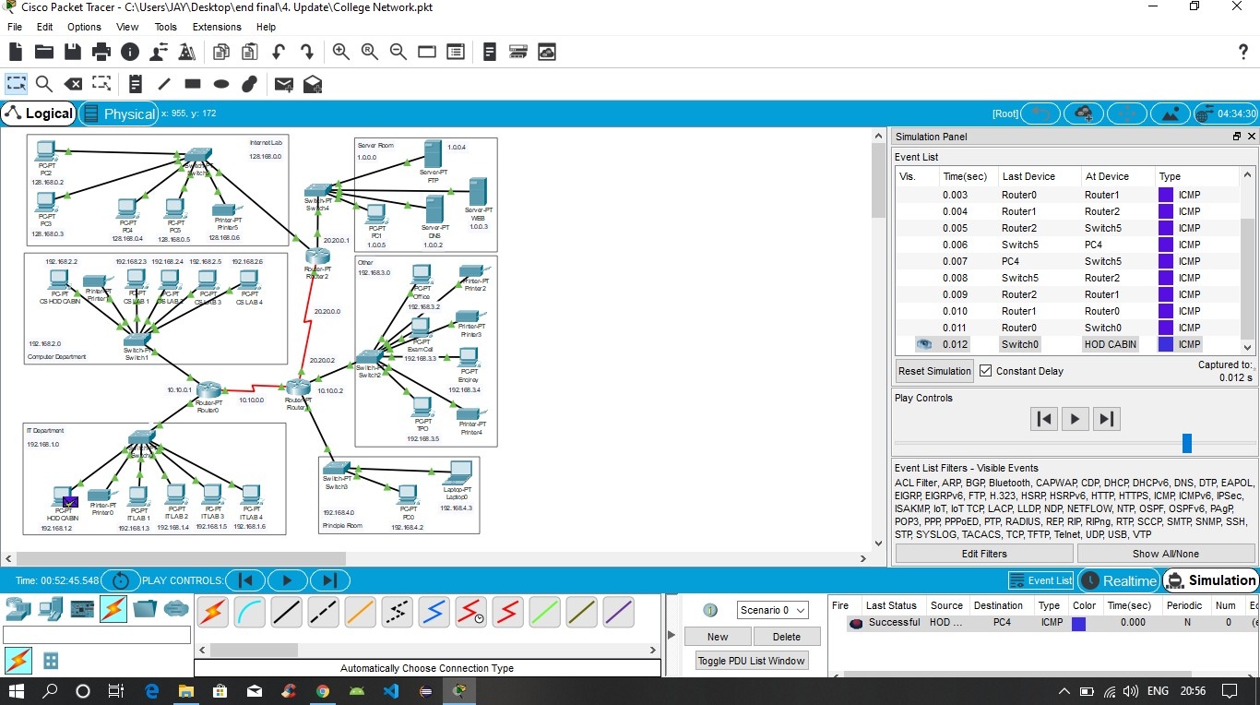

*The prototype of the proposed network is implemented on cisco packet tracer*

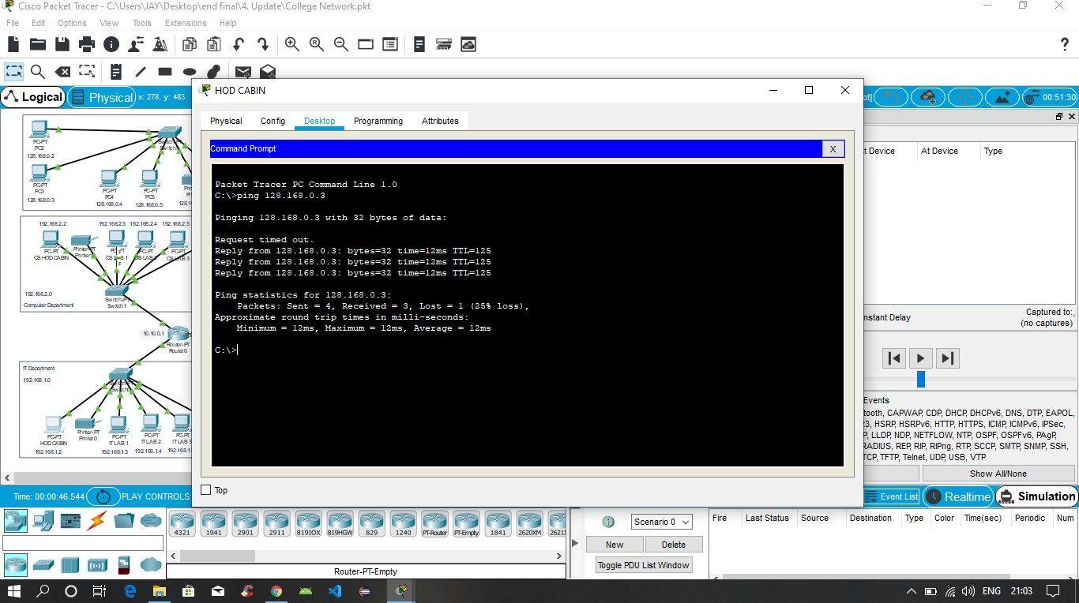

*Testing VLAN communications from HOD Cabin to Internet Lab*

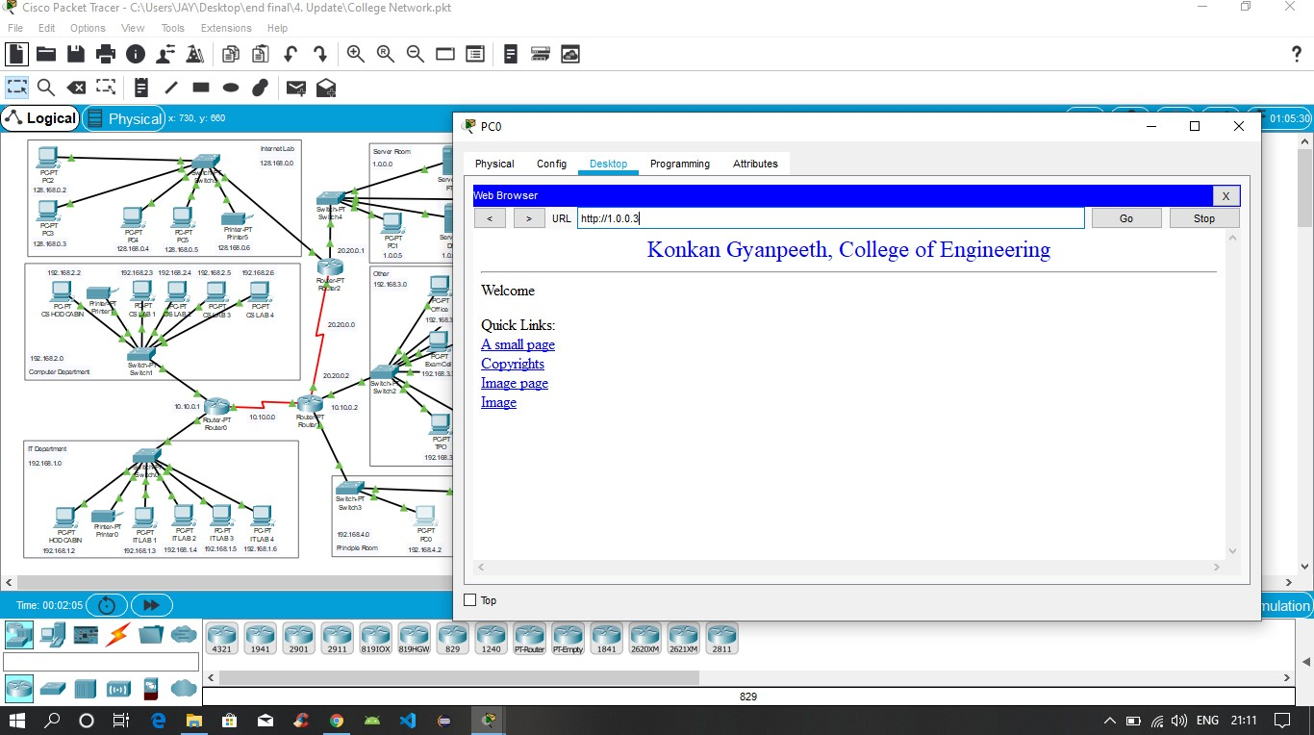

*Testing Web Hosting*

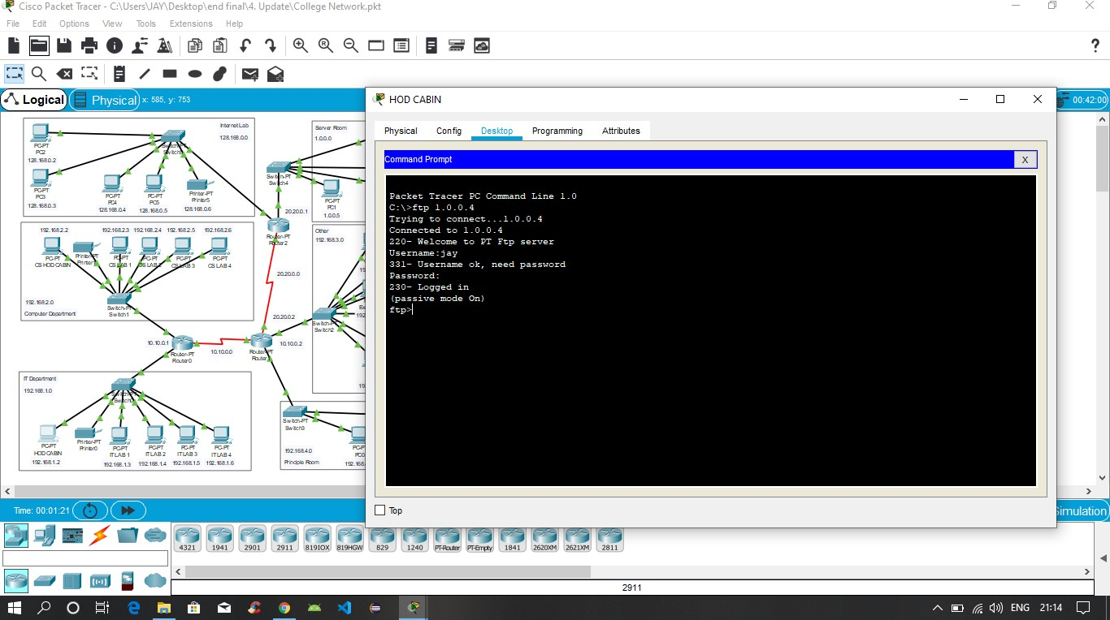

*Testing FTP Server*

**TESTING**

Testing is a crucial phase in the implementation of OSPF (Open Shortest Path First) and network infrastructures. It ensures that OSPF configurations, functionalities, and performance meet the specified requirements and deliver reliable, efficient routing services. The testing process includes several key aspects:

**Test Planning:**

Define testing objectives, scope, and strategies.

Identify test scenarios, test cases, and test data requirements.

Establish testing timelines, resources, and responsibilities.

**Types of Testing:**

Functional Testing: Verify OSPF functionalities such as route calculation, area configuration, neighbor discovery, and route advertisement.

Performance Testing: Evaluate OSPF performance metrics including convergence time, routing table size, link utilization, and network latency.

Security Testing: Validate OSPF authentication mechanisms, encryption protocols, and access control policies to ensure network security.

Interoperability Testing: Test OSPF interoperability with different router models, operating systems, and network configurations.

Scalability Testing: Assess OSPF scalability by simulating large-scale network environments with multiple routers, areas, and network segments.

Failover Testing: Test OSPF failover mechanisms and redundancy configurations to ensure network resilience and fault tolerance.

**Test Environment Setup:**

Configure test environments using network simulation software (e.g., Cisco Packet Tracer, GNS3) or physical hardware.

Deploy OSPF configurations, network topologies, and routing scenarios based on test requirements.

Generate test data, simulate network traffic, and emulate network conditions to replicate real-world scenarios.

**Test Execution:**

Execute test cases, observe OSPF behavior, and capture test results.

Monitor OSPF routing tables, neighbor relationships, routing updates, and convergence processes during testing.

Analyze test outcomes, identify discrepancies, and report issues or anomalies.

**Regression Testing:**

Conduct regression testing to verify OSPF configurations after changes, updates, or enhancements.

Ensure backward compatibility, stability, and functionality consistency across OSPF implementations.

Documentation and Reporting:

Document test procedures, test cases, test results, and observations.

Create test reports summarizing test findings, identified issues, and recommendations for improvements.

Provide feedback to development teams, network engineers, and stakeholders for OSPF optimization and refinement.

By following a structured testing approach, organizations can validate OSPF implementations, mitigate risks, optimize network performance, and ensure reliable routing services in WANs and complex network environments.

**LIMITATIONS OF PROJECT**

**Hardware and Software Constraints:**

Limited availability of high-end routers, switches, and network interfaces for testing OSPF configurations in a realistic WAN setup.

Compatibility issues with certain router models or operating systems may restrict the range of OSPF features and functionalities that can be implemented.

**Budgetary Constraints:**

Budget limitations may impact the procurement of necessary hardware, software licenses, and network simulation tools for comprehensive OSPF testing and implementation.

Cost constraints may limit the scope of scalability testing, performance optimization, and failover mechanisms in the OSPF setup.

**Time Constraints:**

Time constraints may restrict the duration and depth of testing phases, including functional testing, performance testing, and regression testing.

Limited time may also impact the thoroughness of documentation, reporting, and analysis of OSPF implementation results and outcomes.

**Resource Constraints:**

Limited availability of skilled network engineers, administrators, and system integrators may affect the depth of OSPF configuration, optimization, and troubleshooting efforts.

Insufficient resources for network monitoring, maintenance, and incident response may impact the reliability and uptime of the OSPF-based network.

**Complexity of Network Environment:**

Complexity in network topologies, interconnections, and routing requirements may introduce challenges in designing and implementing OSPF configurations.

Integration with existing network infrastructures, legacy systems, and third-party applications may require additional resources and expertise.

**Security Concerns:**

Limited resources for implementing robust OSPF security measures such as authentication, encryption, and access control may pose security risks in the WAN environment.

Vulnerabilities in OSPF configurations or network devices may expose the network to potential cyber threats and attacks.

**Scalability Challenges:**

Scalability limitations in OSPF implementations may impact the network's ability to scale seamlessly with increasing network size, traffic volume, and routing complexity.

Challenges in optimizing OSPF routing tables, managing network growth, and handling dynamic network conditions may affect the network's performance and efficiency.

Addressing these limitations requires careful planning, resource allocation, and collaboration among stakeholders to ensure successful OSPF implementation, testing, and optimization in a WAN environment.

**Conclusion and Future Enhancement:**

In conclusion, the design and implementation of a wide area network (WAN) using the OSPF protocol are as follows :-

* Provide a reliable and efficient method for interconnecting devices and networks over a large geographical area.
* OSPF is a link-state routing protocol that uses a database of the network's topology to determine the best route for data packets to take from their source to their destination.
* It can be used to route traffic over various types of WAN connections, such as leased lines, satellite links, and broadband internet.

There are several potential areas for future enhancement in the design and implementation of a Wide Area Network (WAN) using the OSPF (Open Shortest Path First) protocol. Some of these enhancements will be:-

* Improved scalability: As the size and complexity of a WAN grows, it is important to ensure that the OSPF routing protocol can scale to meet these demands.
* Enhanced security: This could involve adding encryption and authentication to OSPF messages, as well as implementing other security measures such as access control lists and firewalls.
* Improved reliability: This could involve implementing features such as fast convergence and multipath routing to improve the reliability of the network.
* Advanced routing features: OSPF is a powerful routing protocol that supports a wide range of features and capabilities.
* Integration with other technologies: WANs are often integrated with other technologies, such as virtual private networks (VPNs) and cloud computing platforms.

**Bibliography**

1. Sun, L., Wu, J., Zhang, Y., & Yin, H. (2013, April). “Comparison between physical devices and simulator software for Cisco network technology teaching”. In Computer Science &Education (ICCSE), 2013 8th International Conference on (pp. 1357-1360). IEEE
2. Roberto Minerva AbiyBiru, "Towards a Definition of the Internet of Things” IEEE IOT Initiative white paper.
3. “Design and Simulation of Local Area Network Using Cisco Packet Tracer”. The International Journal of Engineering and Science (IJES) || Volume || 6 || Issue || 10 || Pages || PP 63- 77 || 2017 || ISSN (e): 2319 – 1813 ISSN (p): 2319 – 1805.
4. Qin, X. U. E. "Simulation Experimental Teaching of Computer Network Based on Packet Tracer [J]." Research and Exploration in Laboratory 2 (2010): 57-59.
5. Current, John R., Charles S. ReVelle, and Jared L. Cohon. "The hierarchical network design problem." European Journal of Operational Research 27.1 (1986): 57-66.